# Green areas, air quality and density of population in Yerevan

**Description of how different layers for web applications were created**

Jan Boril

Masaryk University/Yerevan State University

Sep 2021 – Jan 2022

borekj.jan@gmail.com

For a web I was creating, I created three independent layers about the city of Yerevan - Green areas, Air quality and Density of population. In this manual, I will describe what I did and how was the results.

I used sources from USGS, OSM, Google Earth, Wikipedia and data that I obtained with the help of my professors.

# Green areas in Yerevan

I obtained my data from USGS website. I downloaded 4 Landsat 7 images from years 2000-2003 and 9 more from Landsat 8 from years 2013 – 2021. Years 2004 -2012 were skipped because of known “strip” problem of Landsat 7. Data were downloaded in period between March and June in each year, for every year a picture with clear sky was chosen. The “wide” period for obtaining images caused some problems, more on that later. The images have resolution of 30 metres.

### Methodology

I worked mostly with building index (BI), which is calculated by the difference between NDBI ((SWIR – NIR)/(SWIR+NIR)) and NDVI ((NIR – Red)/(NIR + RED)) indexes. This index was calculated for every year, resulting raster was clipped into the shape of Yerevan region (obtained from OSM).

A threshold was need to set up for selecting “green” areas. A problem occurred here – since air quality, temperature and other characteristics influencing all three used bands were different in every year, unique threshold value had to be examined and applied for all years. Still, there were many problems in areas that are not covered by buildings, but neither by vegetation – typically in the east part of the city. These areas could be probably classified as a “desert”, but definitely not as green areas (see Fig. 1). A complete result for year 2001 can be seen on Fig. 2.

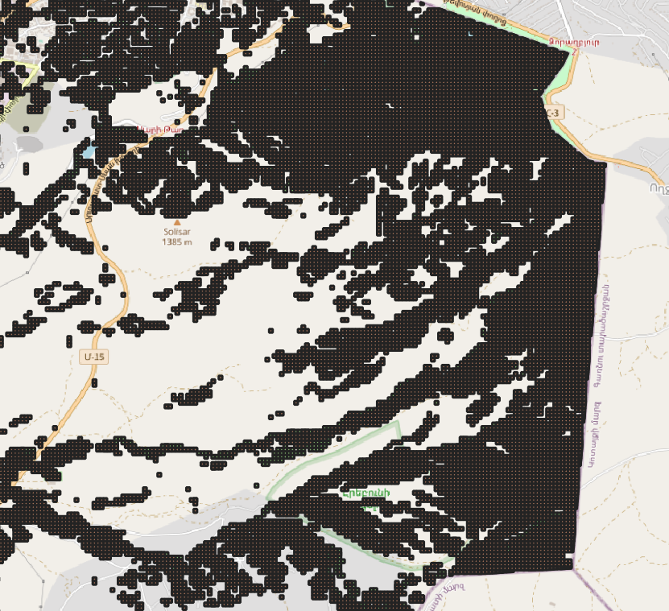 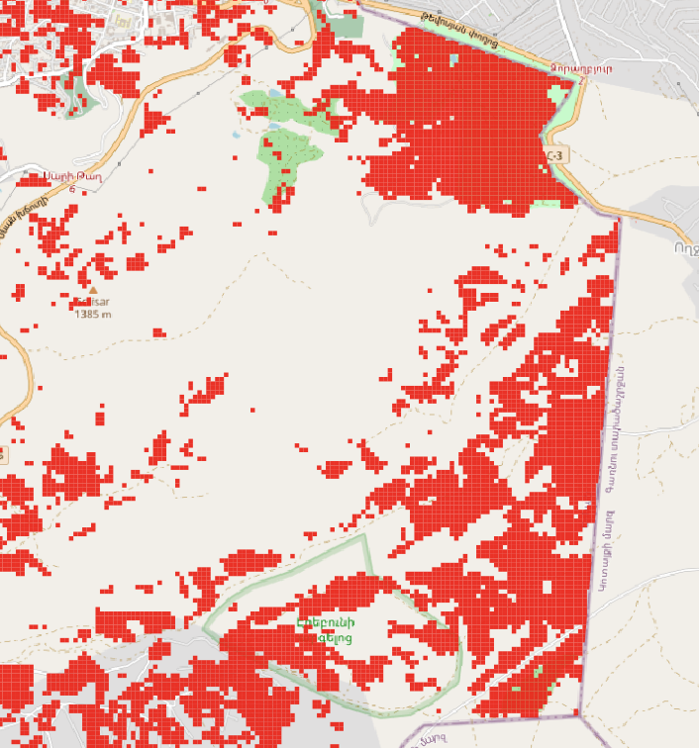

Fig. 1: „desert“ area in years a) 2021 b) 2000

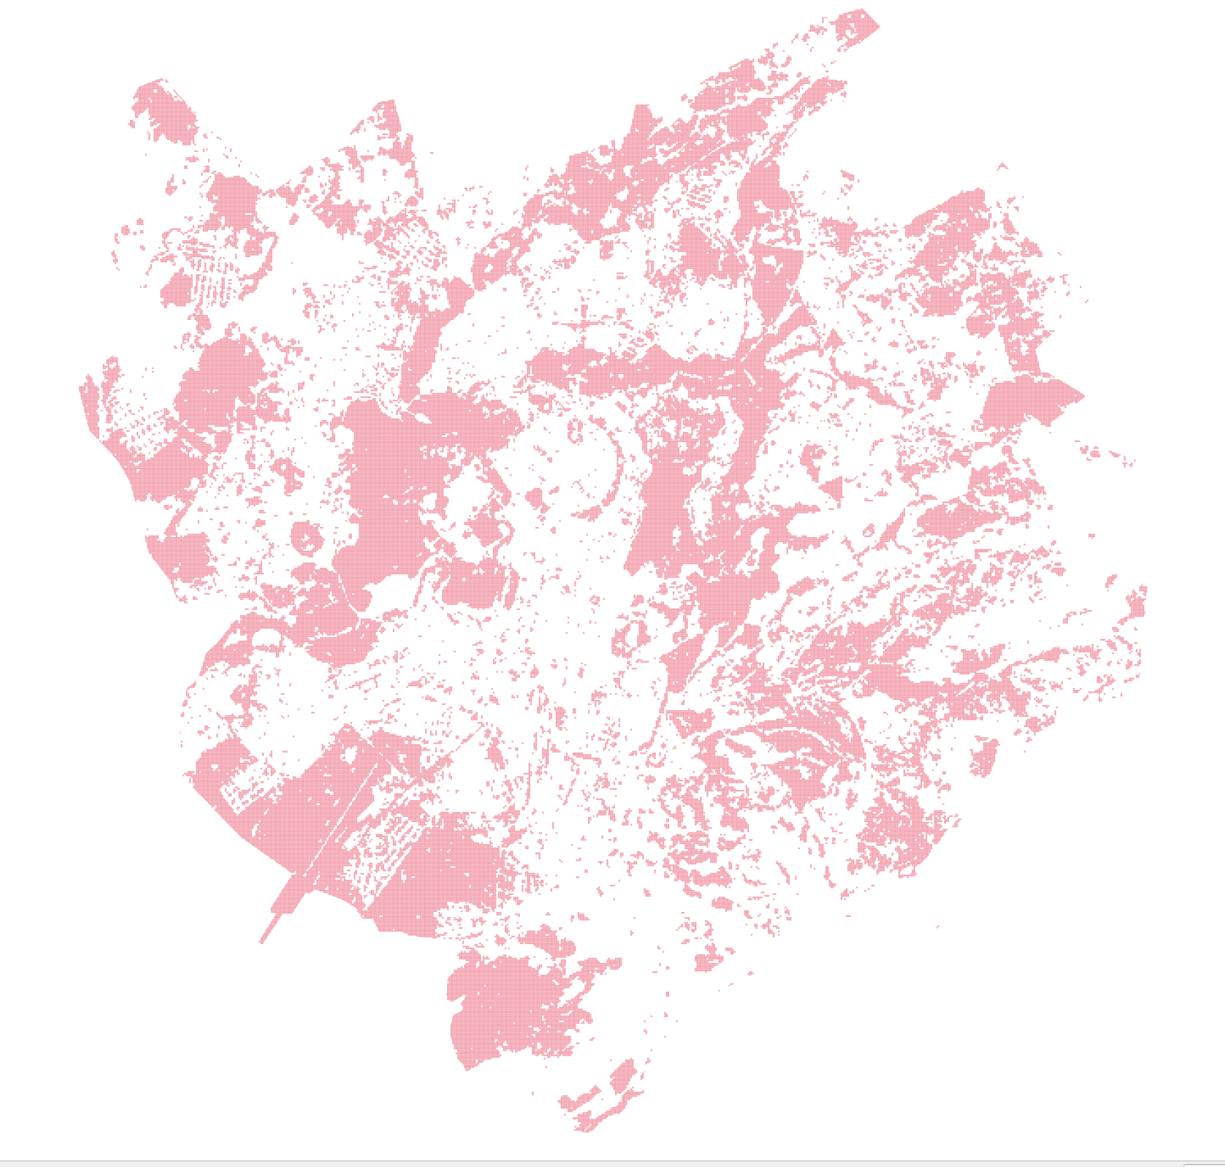

Fig. 2) Green areas based on threshold method in 2001.

One method how to find differences between years would be to geometric difference between years and resulting polygons would be the decrease of green areas. However, this method showed a large amount of inaccuracies, since the “green areas” polygons were in quite big difference in consecutive years due to a different atmospheric conditions. You can see a result of difference between years 2021 and 2000 on Fig. 2.

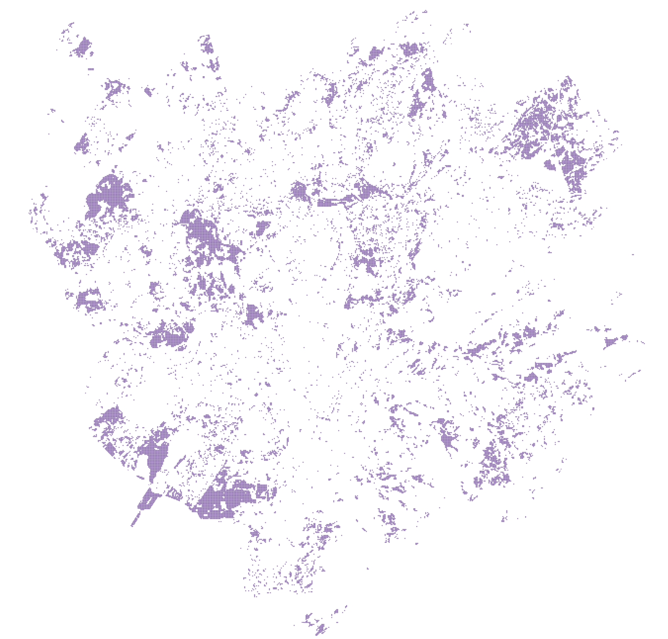

Fig. 3: Decrease of green areas between years 2021 and 2000 based on difference of these years

Another approach was used. An average of years 2000-2003 was calculated. Then a difference has been made with averages from years 2013-5, 2016-8 and 2019-2021. Results for such an approach between years 2000-2003 and 2019-2021 can be seen in Fig. 4. It is clear that approach used in Fig. 4 got more promising results than approach used in Fig. 3.

Results were the dissolved and all polygons containing less then three cells were deleted.

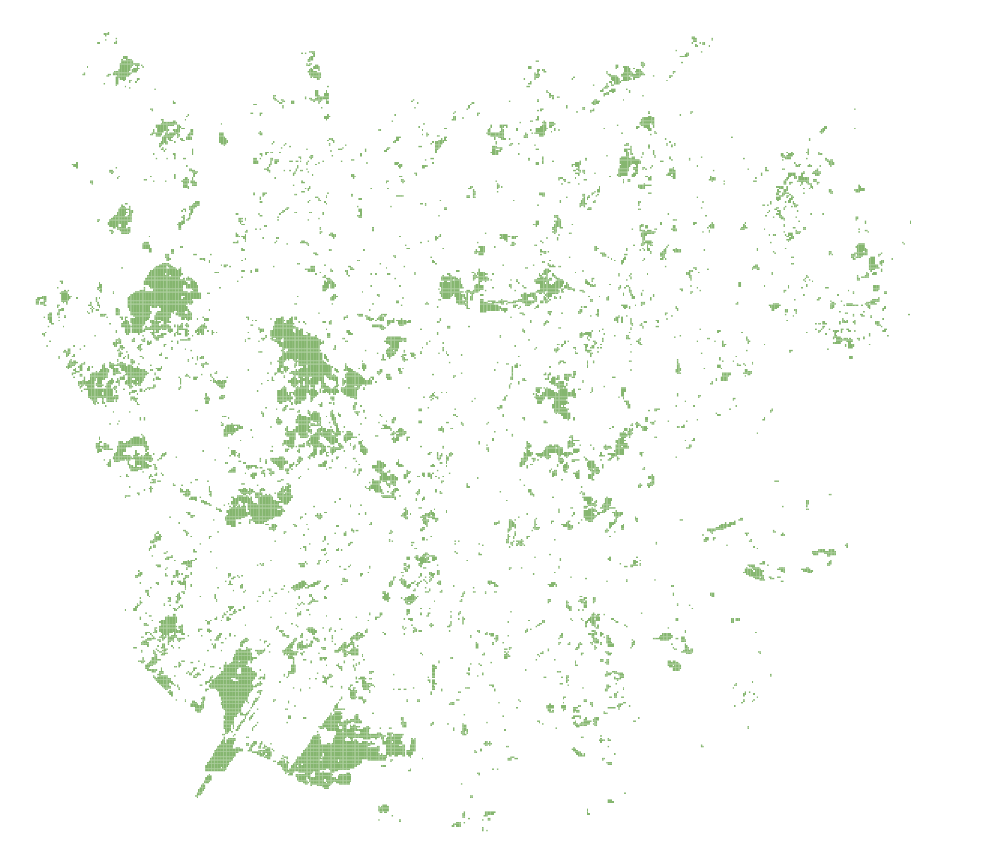

Fig. 4: Decrease of green areas between years 2000-2003 and 2019-2021 based on difference of averages

### Results

Given methodology got several areas, where a decrease in green areas can be spotted. In some areas, the results can be easily confirmed via a time-archive in Google earth, such as in Fig.5 (south of the city) or Fig. 6 (north of botanical garden).

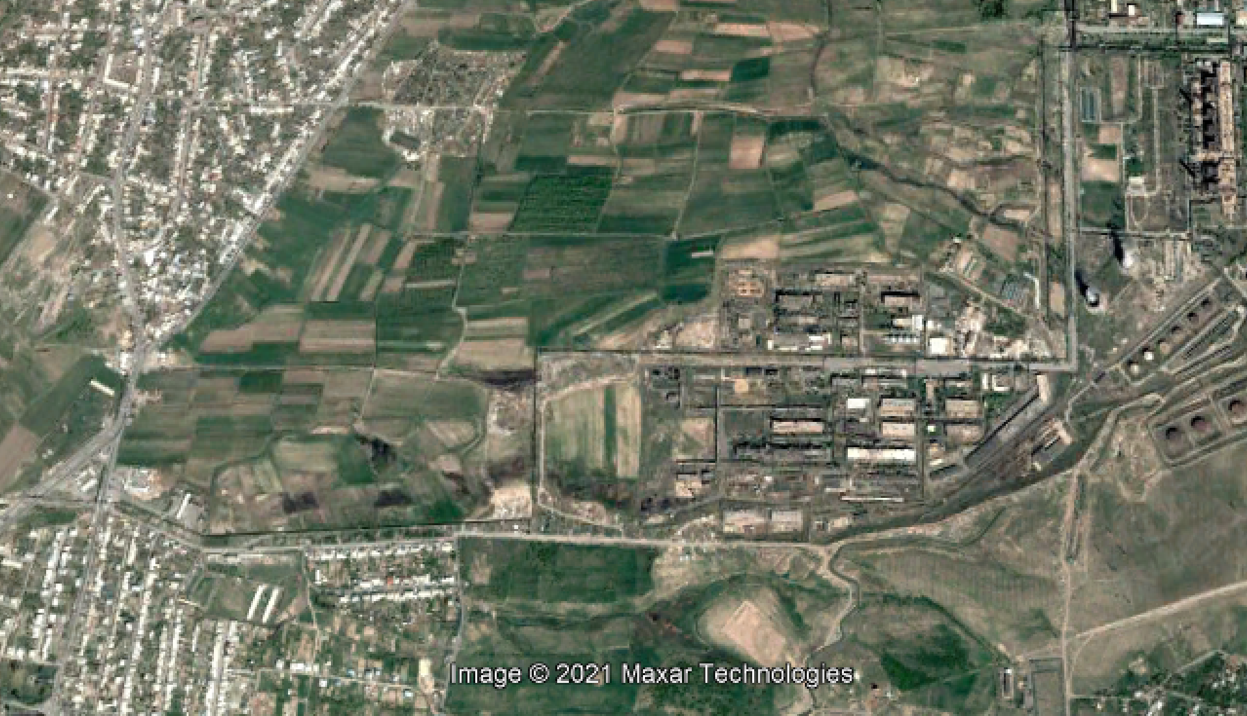 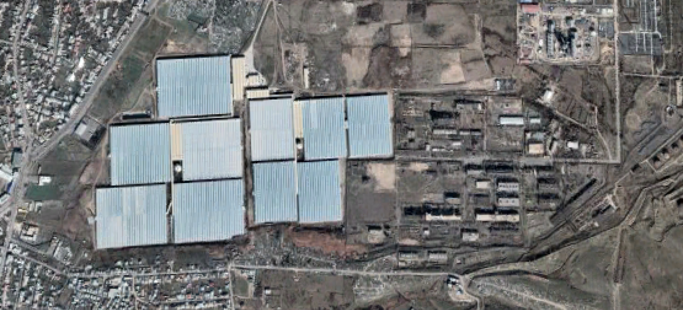

Fig. 5: newly built areas in south of the city (2000 and 2021)

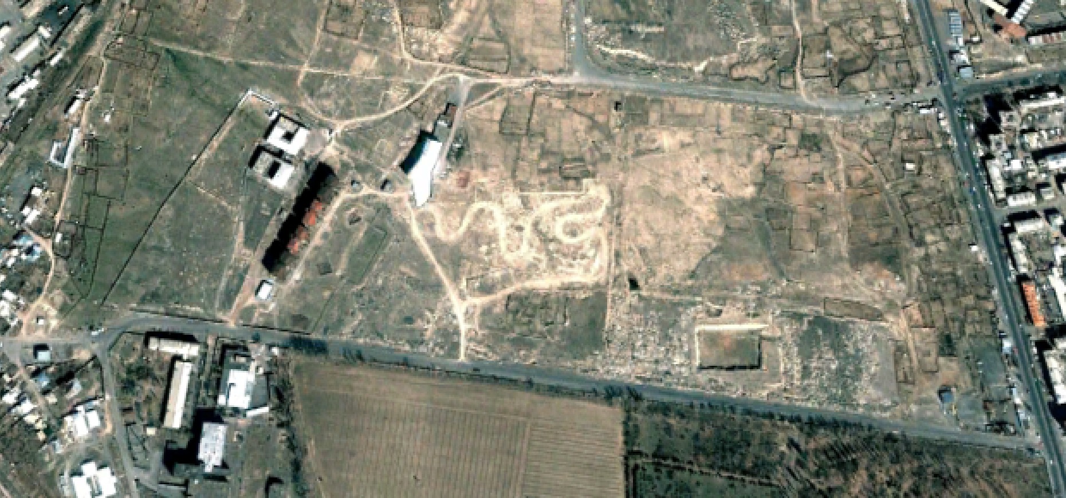 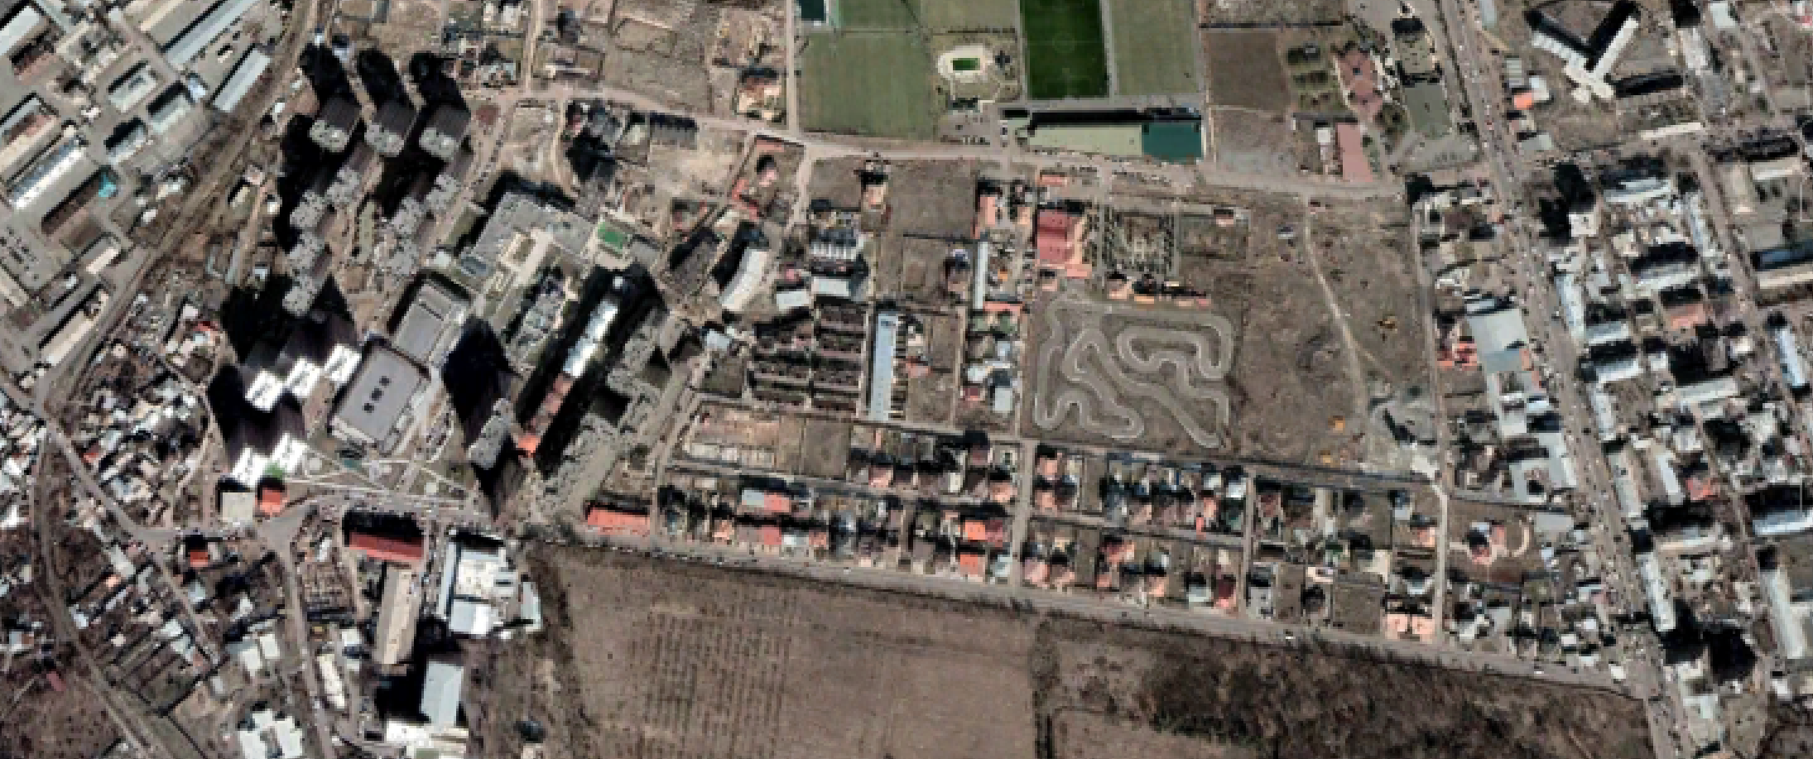

Fig. 6: newly built areas north of botanical garden (2000 and 2021)

In some areas, it is not possible to see new built-up areas, but rather a decrease in green area quality, see fig. 7

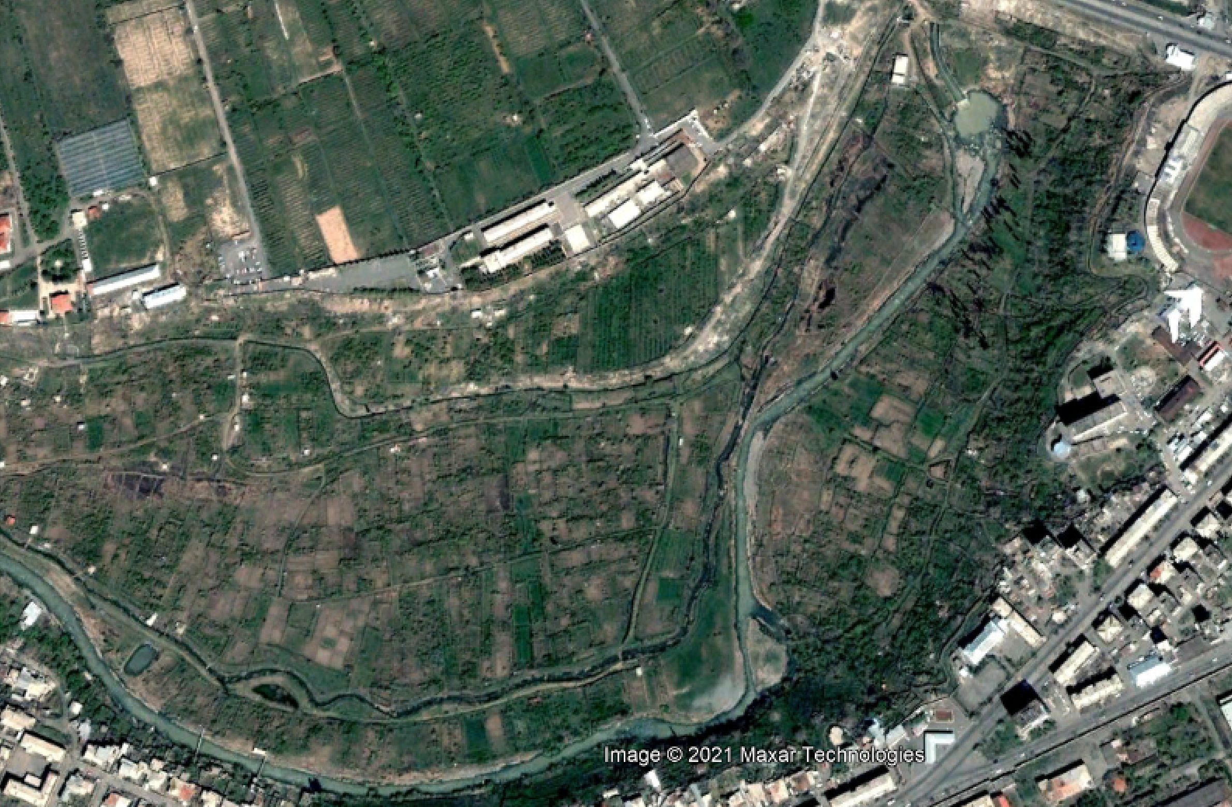 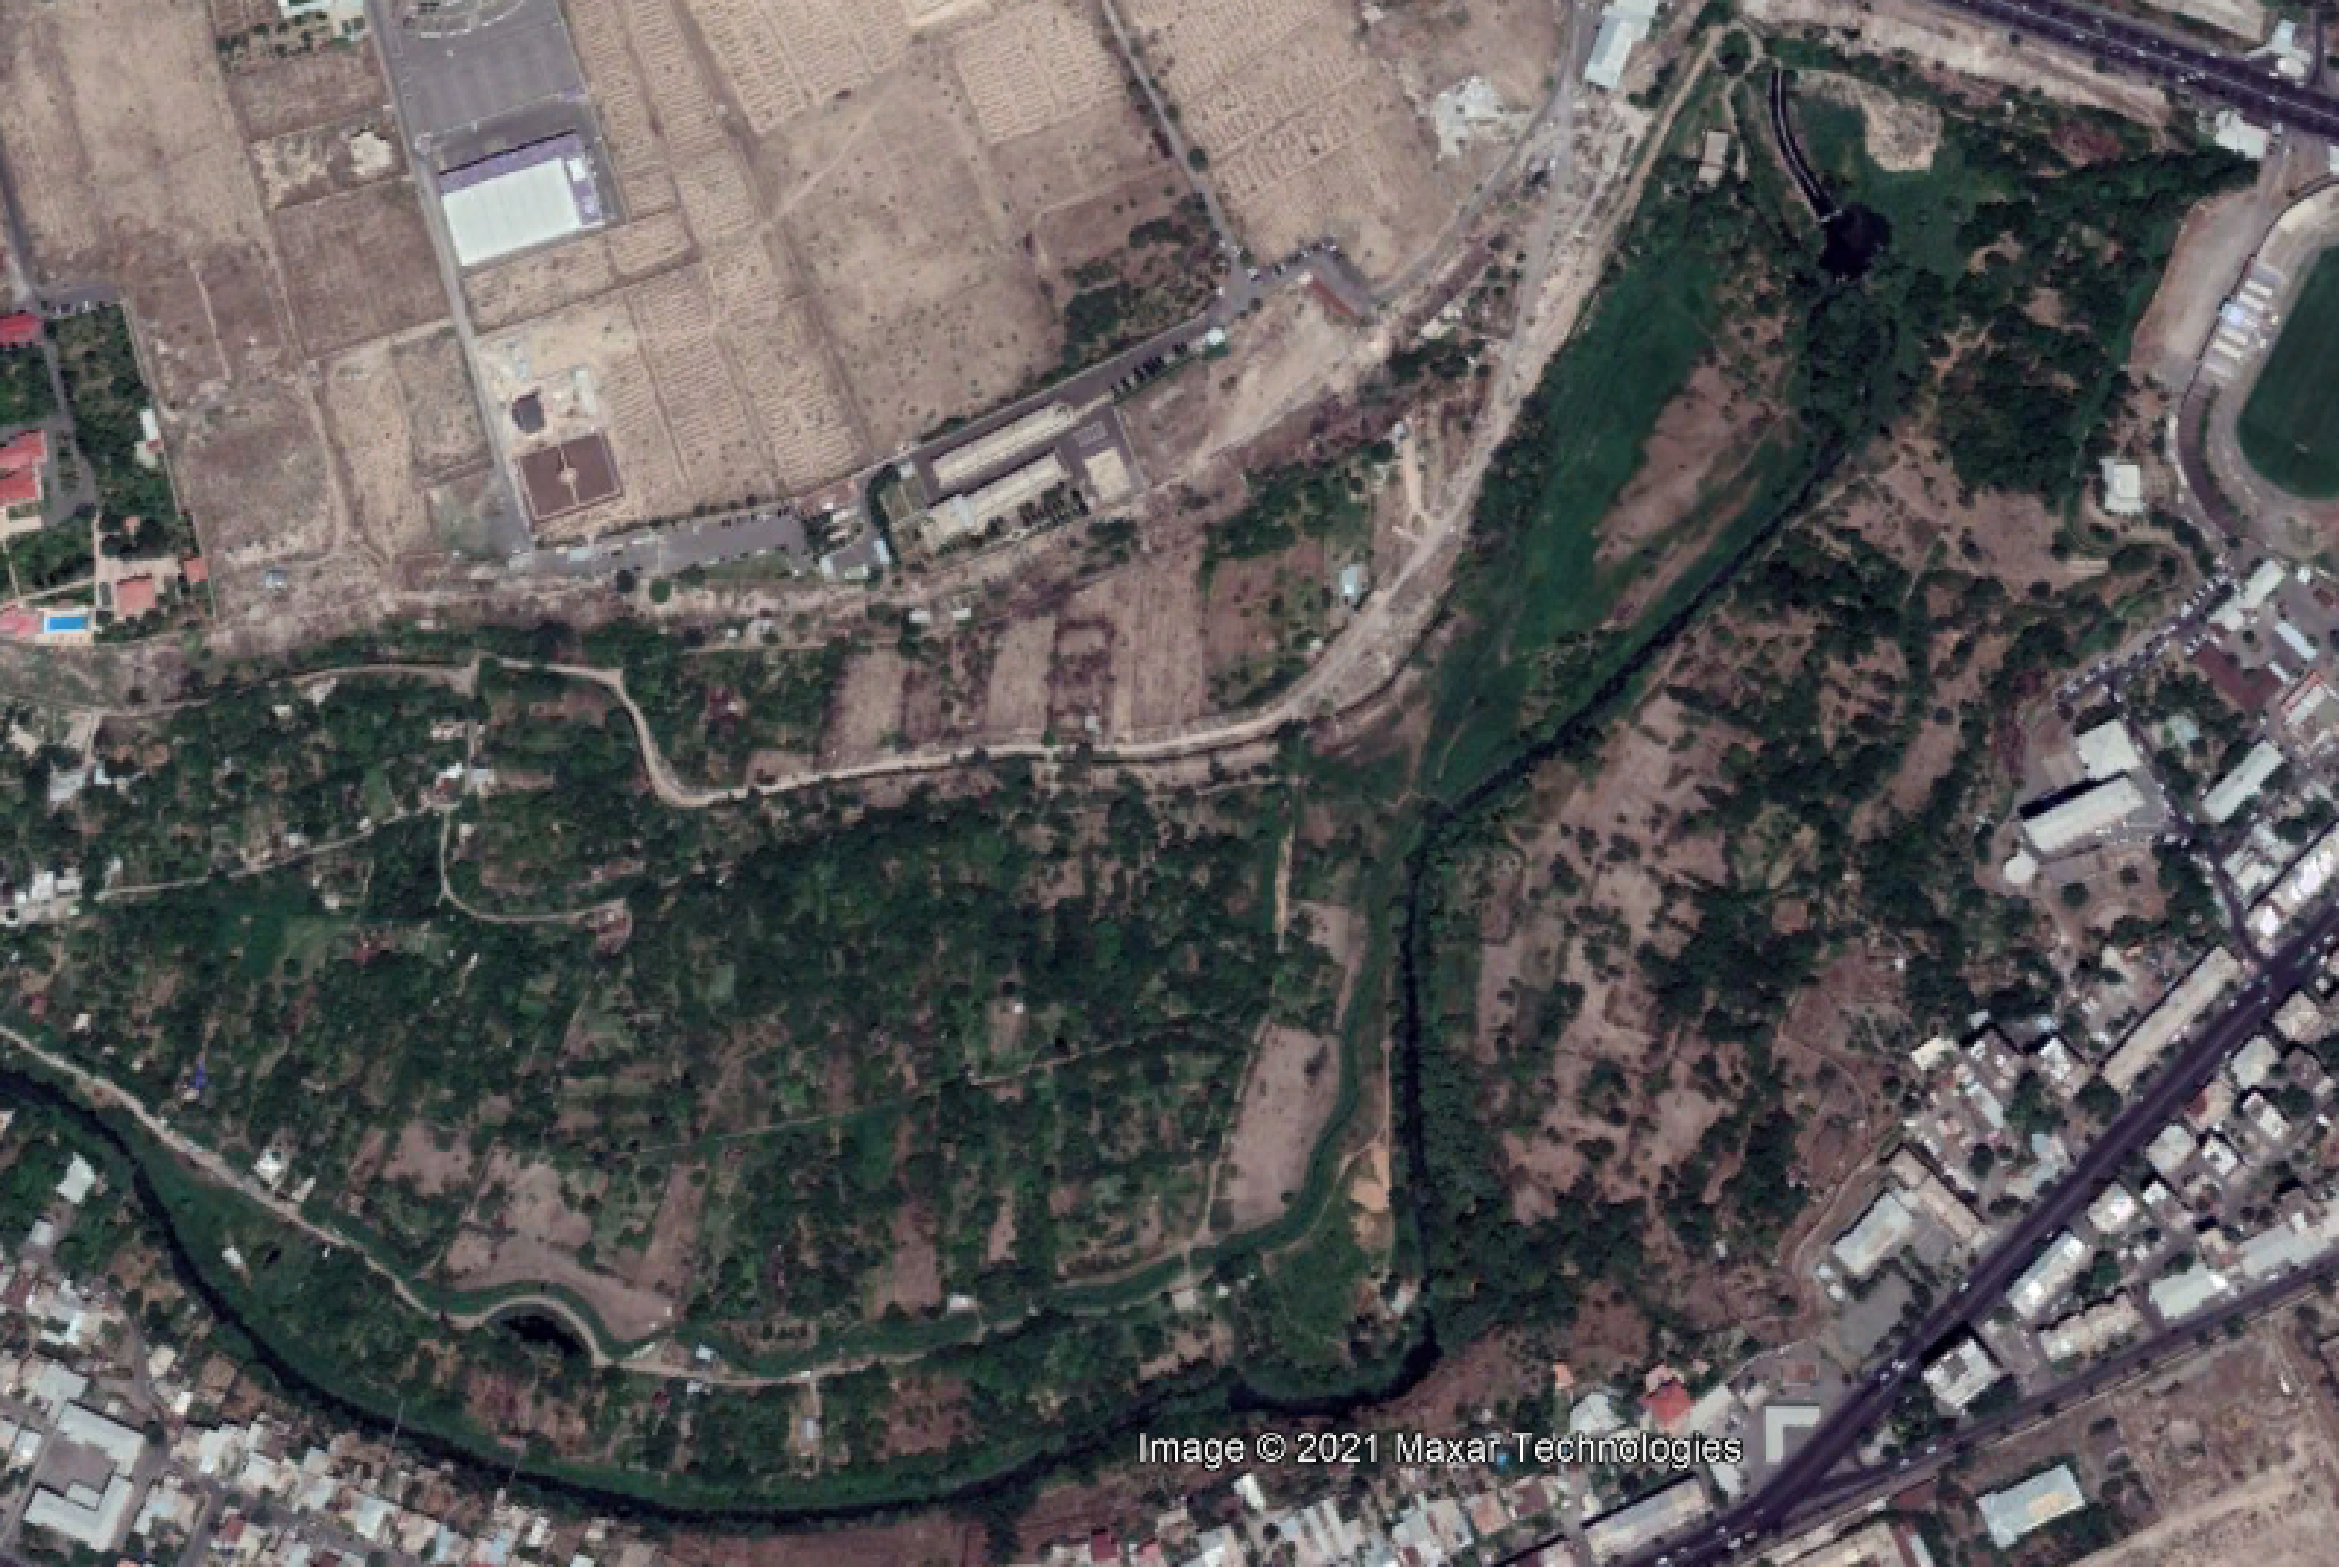

Fig. 7: decrase in the quality of air

In Fig. 8 it is possible to see a graph of green areas as a share of total area. It is pretty clear that the biggest decrease happened in first three years and the decrease in next 8 years is very little – it is hard to decide if it is more caused by actual decrease or by a statistical error.

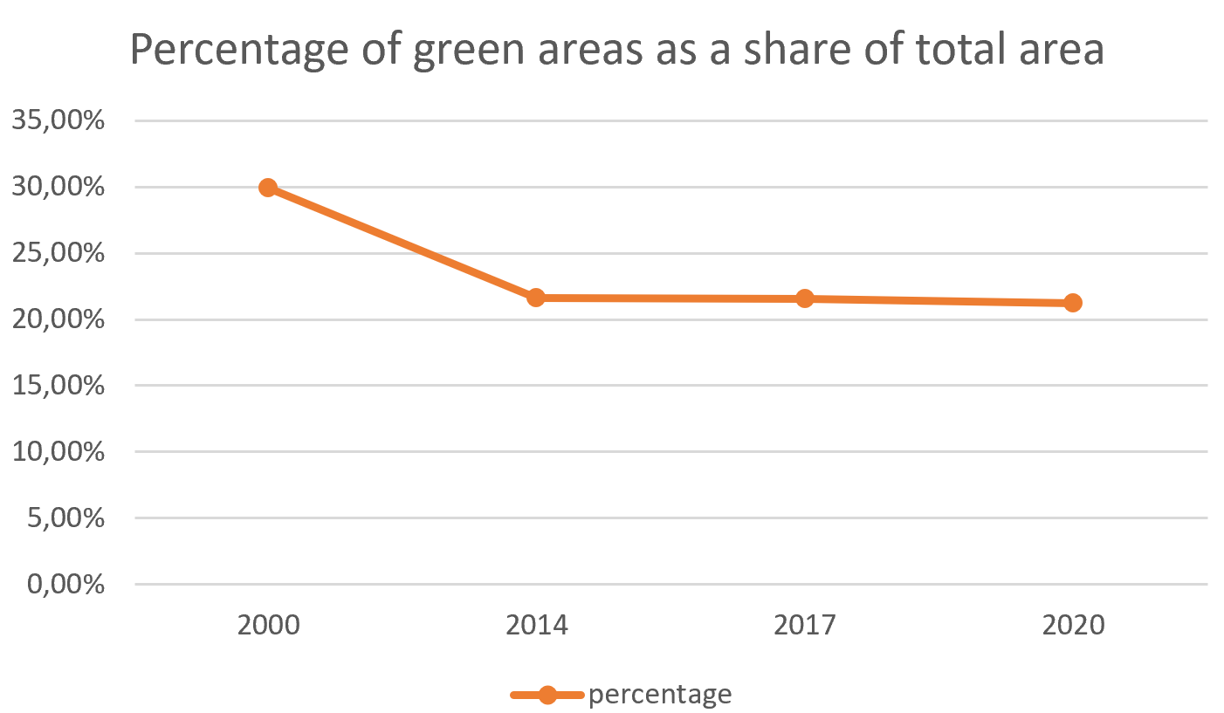

Fig. 8: Percentge of green areas as a share of a total are

## Problems

There are three problems that are worth mentioning. Resolution of data is quite low – only 30 metres per pixel. Although there are now much more precised method with resolution of only few metres, around the year 2000 is Landsat the most accurate satellite, that’s why it was chosen. It wouldn’t make much sense to make later data more precise, since they would be still be dependent on the original resolution of 30 metres.

There are no data available between years 2004 – 2012. Landsat 7 satellite sensor has a known “strip” problem, where you have to compute rows of about 5 pixel rows from neighbouring rows. This calculation however doesn’t make sense in this project, since it is important to know a value of every single pixel.

Slightly different values in BI (building index; caused by taking the image from different months based on the best cloud disappearance) caused inability to the same threshold values for each year, therefore an average of three years had to be made in order to level this inaccuracy.

# Air quality

I obtained the data about air quality with the help of my professor.

Data I worked on were very poor quality. I got only 7 points for a given dates from 2011 to 2021, sometimes the data were missing for some points, so in some years I could work only with 4 points. I did Inverse distance weighting inter- and extrapolation since it was the only inter/extrapolation sensible with given amount of points. Kriging was not possible and LPI didn’t make sense. I extrapolated the area onto the shape of city of Yerevan.

### Problems

Lack of data – very apparent. If I could get more data from more points, I believe I could have gain much more interesting results.

### Results

Given data – maybe surprisingly, maybe not – prove there is NOT any decrease in air quality in Yerevan in given years. You can see examples for some years in fig. 2 – 5. In fig. 6, it is clearly seen that none of the indexes is increasing and therefore decreasing the quality of air.

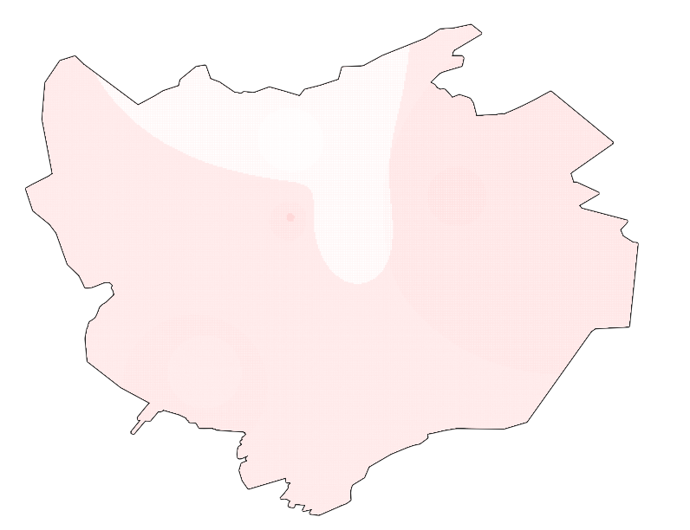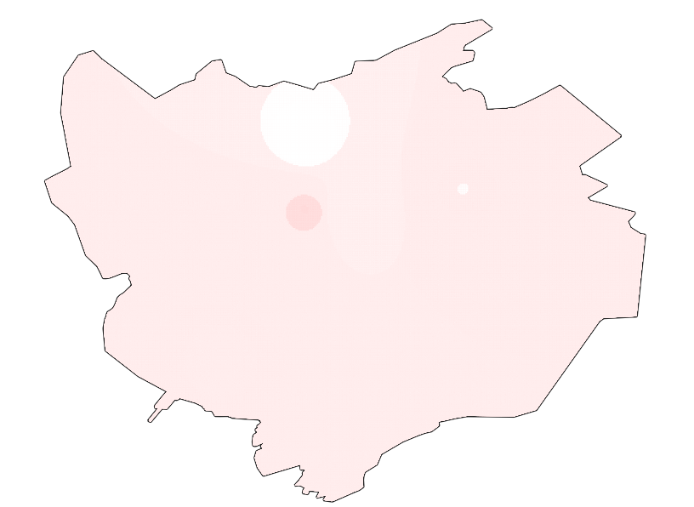

Fig. 9ab) Sulphure in years 2011 and 2021

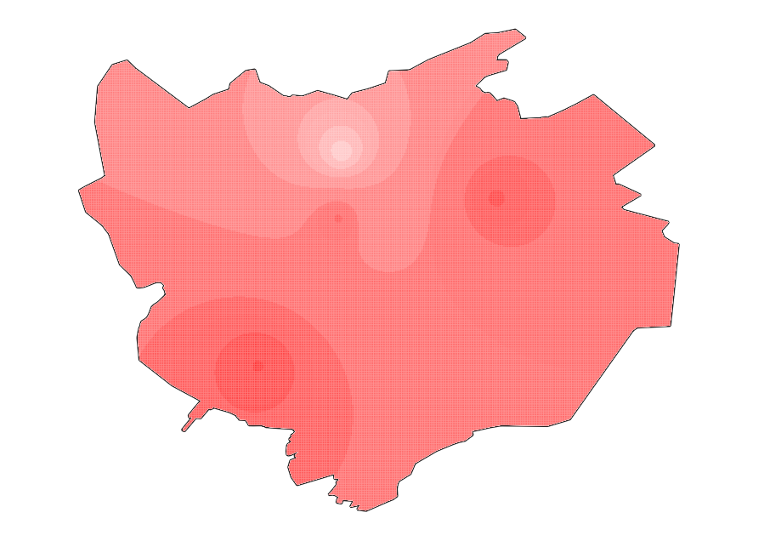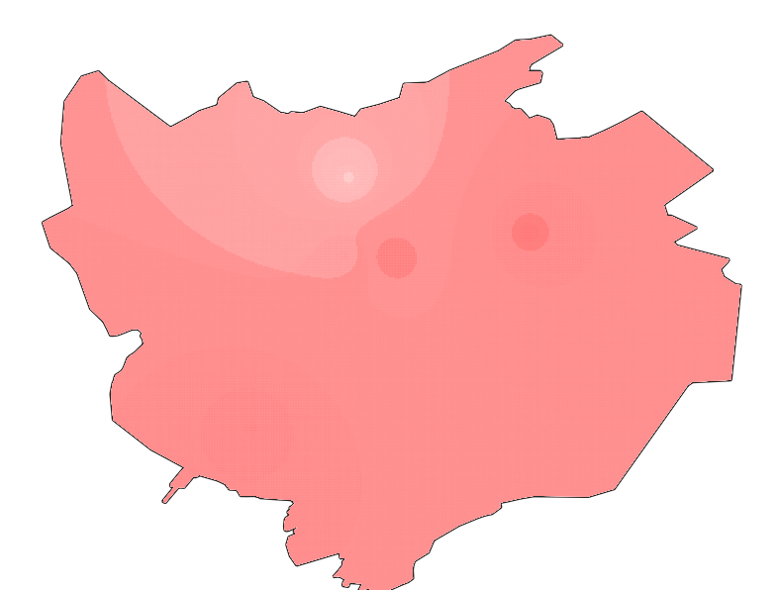

Fig. 10ab) Ozone in years 2012 and 2021

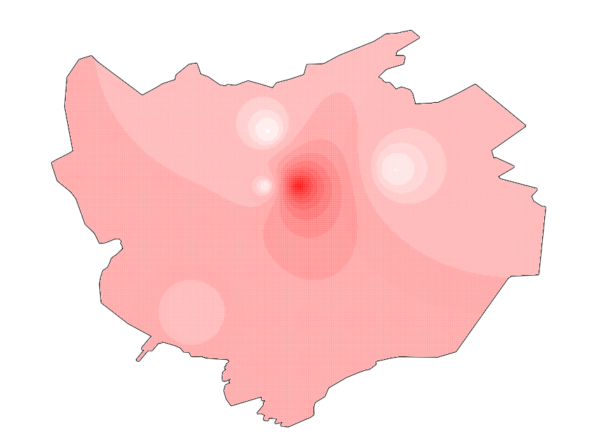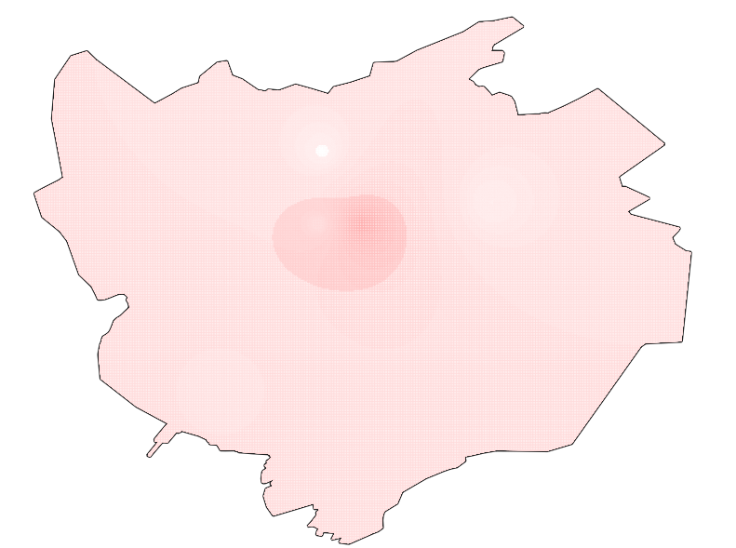

Fig. 11ab) Nitrogen in years 2011 and 2021

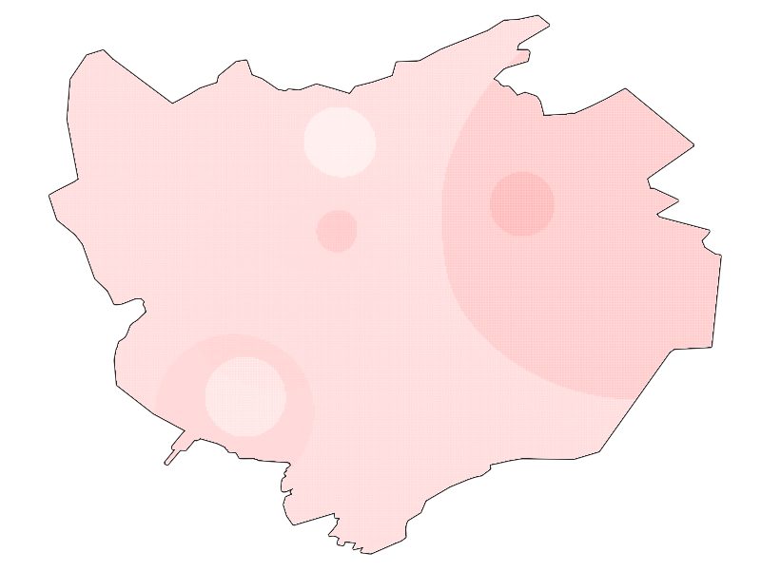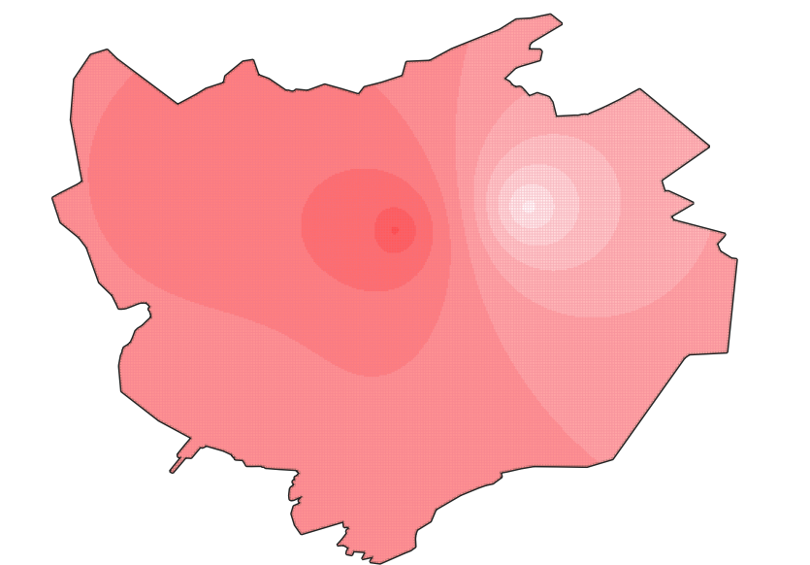

Fig. 12ab) Dust in years 2011 and 2021

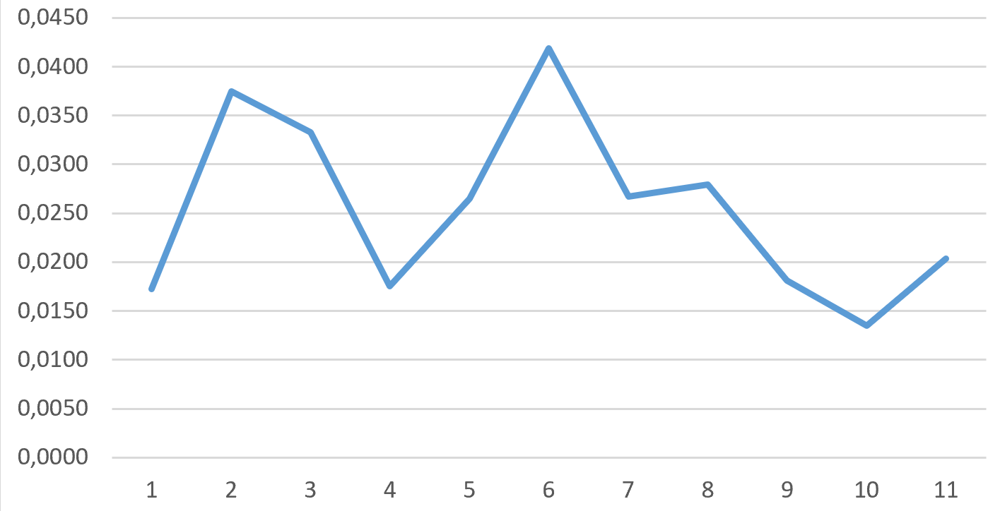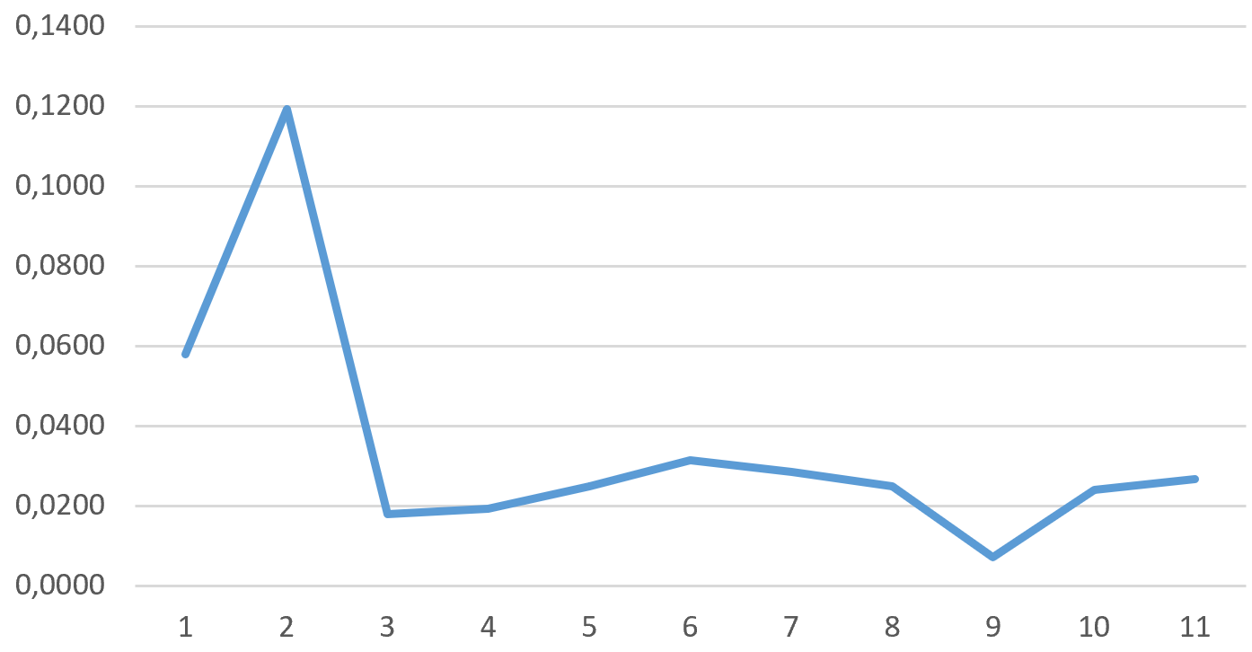

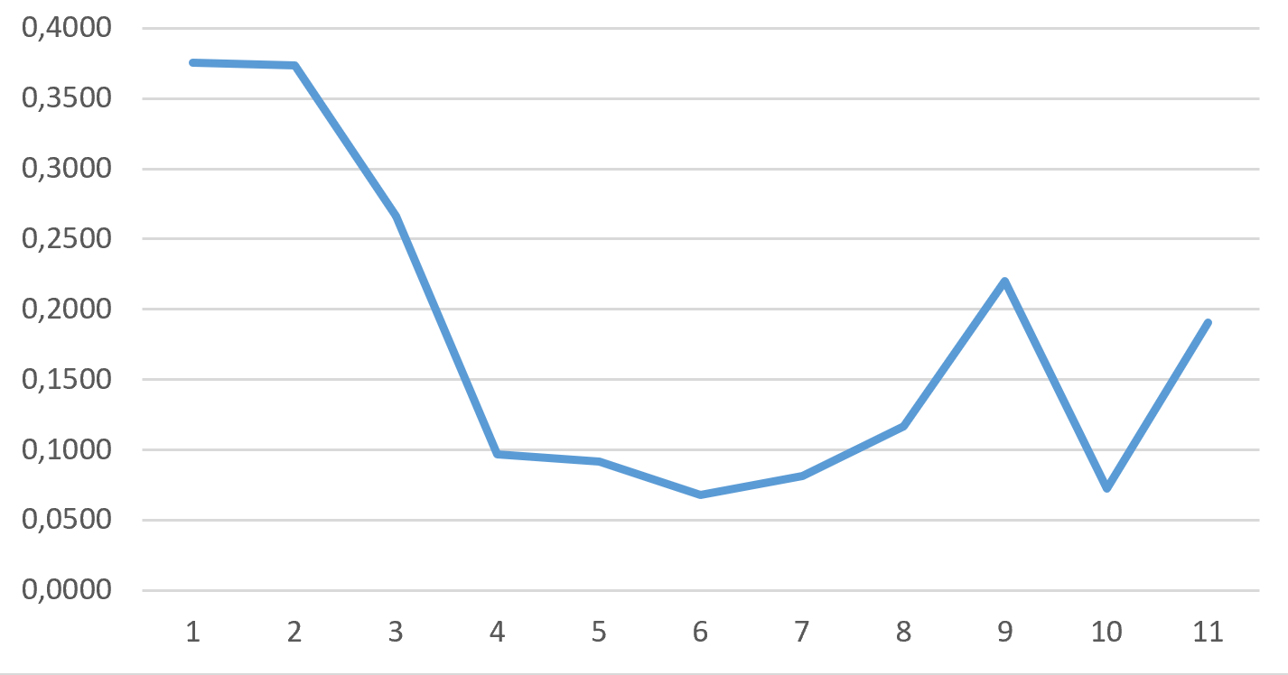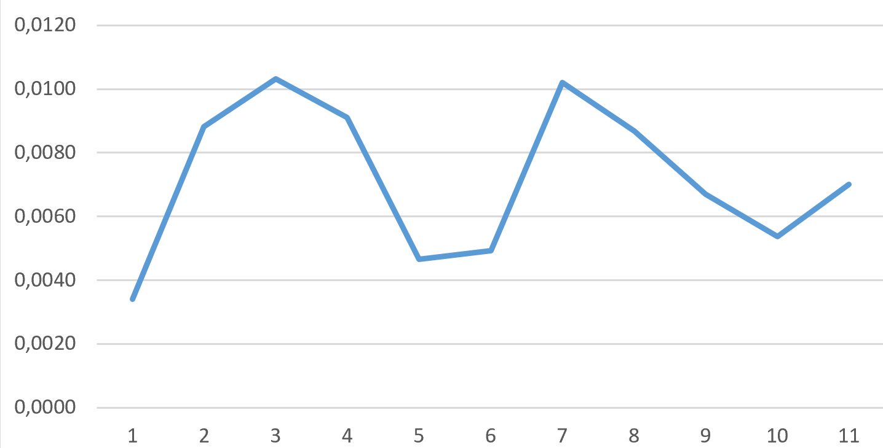

Fig. 13abcd) Sulphure dioxode, Nitrogen dioxode, Dust, Ozone

# Density of population

This layer was the easiest to produce – data about districts were downloaded vis overpass turbo from OSM, data about population in given districts were obtained from [Wikipedia](https://en.wikipedia.org/wiki/Districts_of_Yerevan).

It than took only simple calculation in QGIS to calculate the actual density of each district.

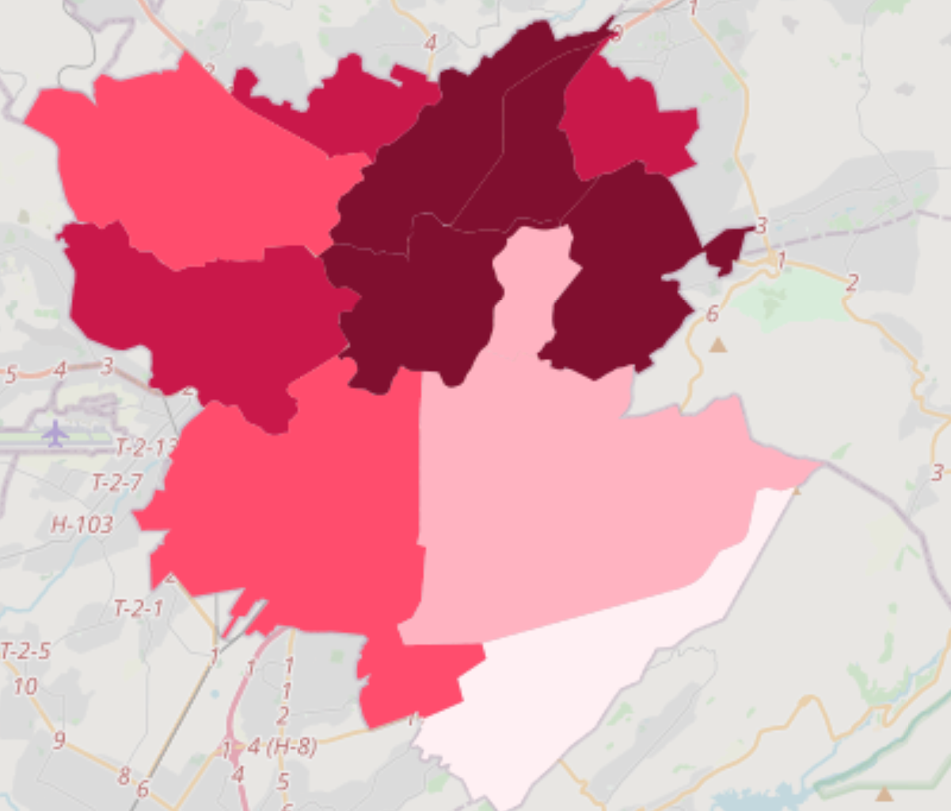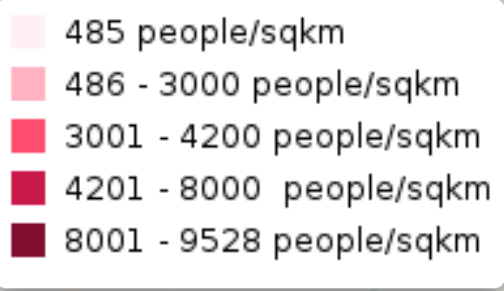

Fig. 14: Density of population in each district (with legend)